**How To Install SPSS 23.0 in MicroSoft Window 10**

1. Run The Setup File.

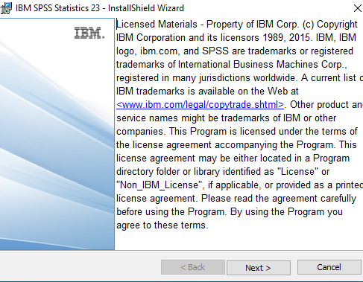

1. Select the “Concurrent user License Option” and Click the “Next” Button.

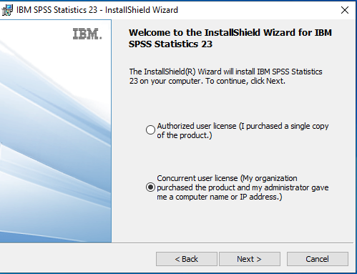

1. Accecpt The Licence Agreement and click the “Next” Button

.

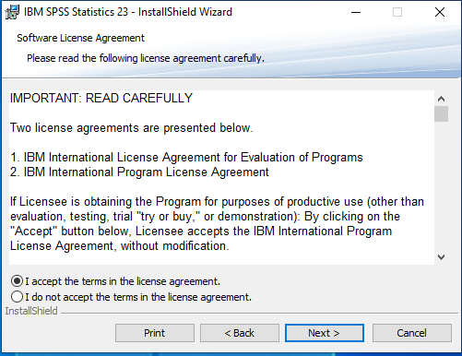

4.Input the “License Server IP Address” . Network License Server for IIT Campus is “172.31.1.147”

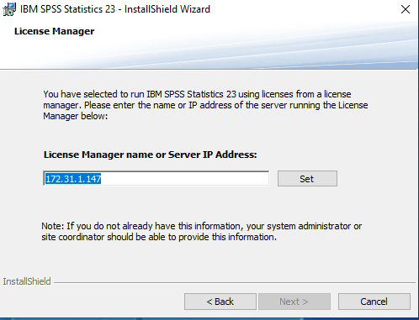

5. English Help Language will be Automatically Installed, if we Select Another Language click the Checkbox and click “NEXT” to continue.

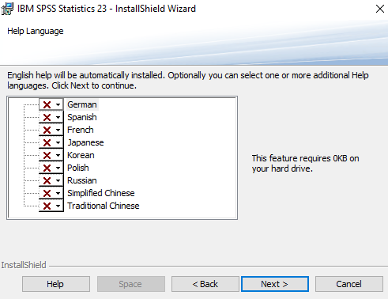

6. Select “Assistive Technology” Option as Required and Click “Next”to Continue.

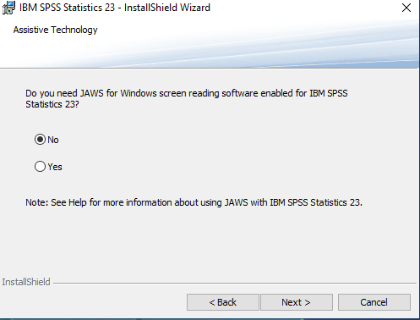

7. Select “Yes” to install “Python” support for SPSS23 and click “Next” to continue

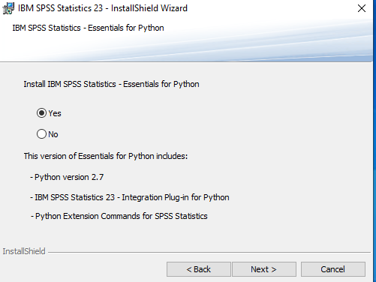

8. Accept the Licence Agreement and “Click” on “Next Button”

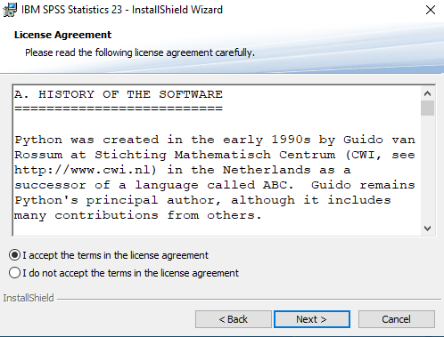

9. Select the again Software License Agreement and then” Click Button” Next Button

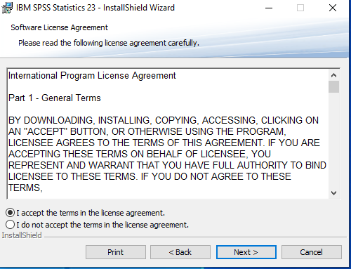

10. Click “ Next” Button to Continue.

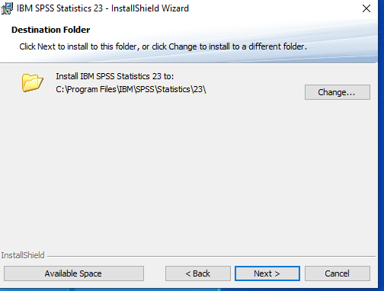

11. Click on “Install” Button.

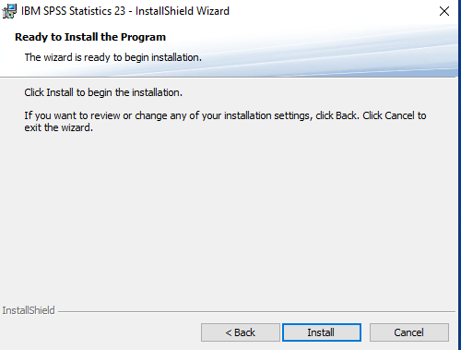

12. Installation Process are running.

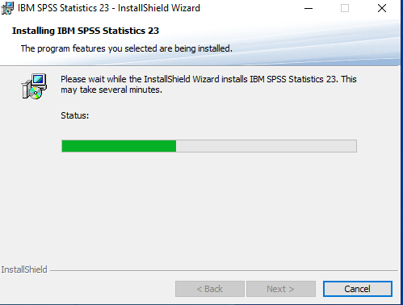

13.Installation will be Completed and Click the “Ok” Button.

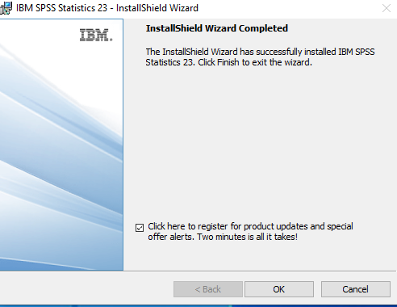

14.Then click the “Finish” Option.

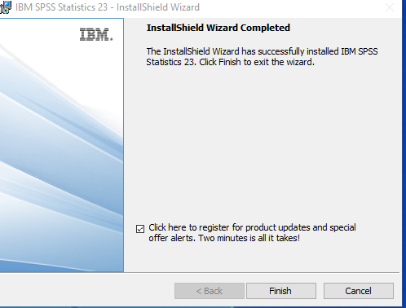

15.If you want to system Restart or Not

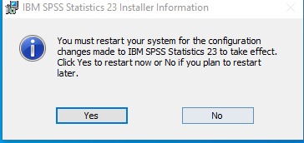

16. The preview of software as Below.

. tr